Ref. No. 205/SFC/DJ/24

From:
The Principal,
Southfield College,
Darjeeling

To,
The Assistant Director of Public Instructions,
Govt of West Bengal,
Education Directorate,
Bikash Bhavan, 6th Floor,
Kolkata – 91 Dated: 27.09.2024

Subject: Confirmation of No Suspension Cases for Teaching
and Non-Teaching Staff at Southfield College, Darjeeling.

Sir,
In response to your WhatsApp message dated 27.09.2024, I would like to inform you that there have been no suspension cases involving teaching and non-teaching staff at Southfield College, Darjeeling, 734101, West Bengal, during the current academic year 2023-2024, as well as in the past. Our institution prides itself on maintaining a professional and supportive environment for all staff members, ensuring that any issues are resolved through constructive dialogue and appropriate measures.
In this connection, I would also like to inform you that we continuously strive to uphold the highest standards of conduct and performance among our staff.
Thanking you,
Yours faithfully,
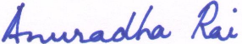
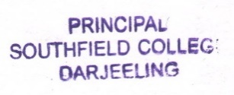
Dr. Anuradha Rai,
Principal,
Southfield College,
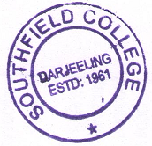
Darjeeling

